1. Whenever I close and open the chat window it shifts position

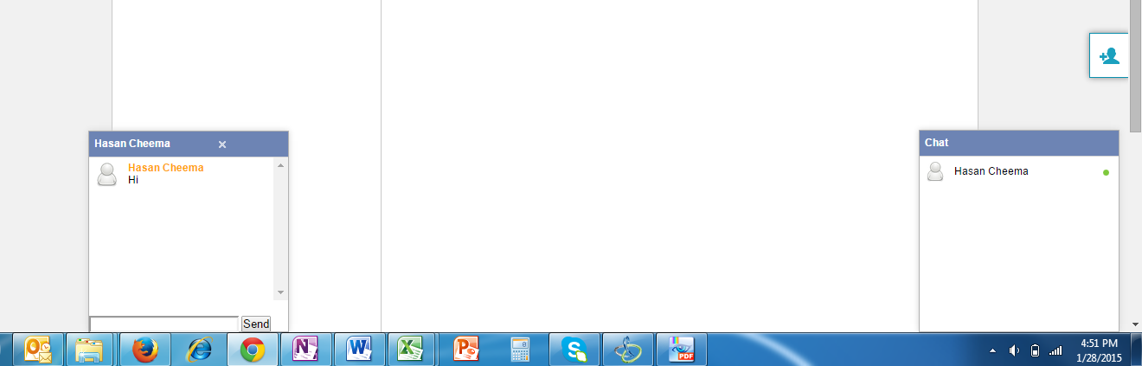

1. The chat window drift out of the screen and I get the message

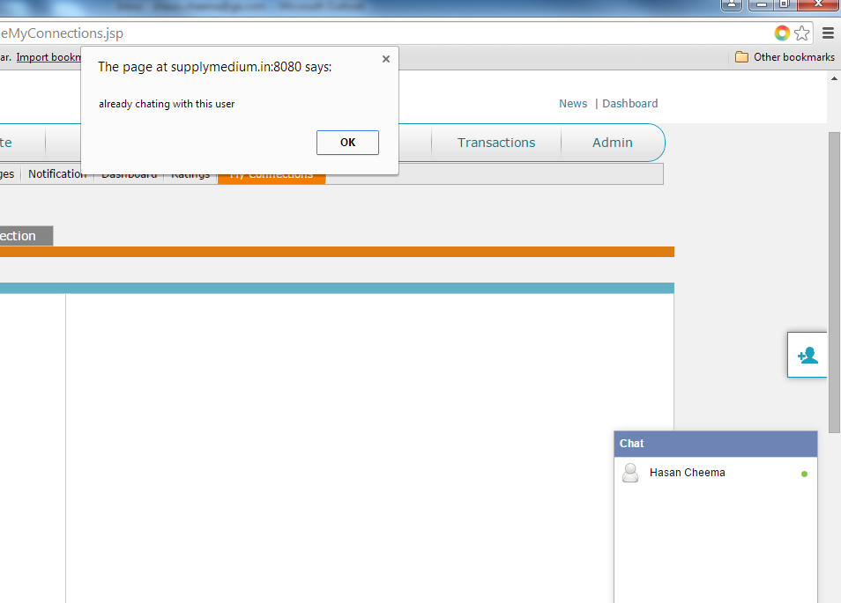

1. The enter button doesn’t work in chat. Have to press Send
2. In Firefox I tried to send a vendor registration form and got this

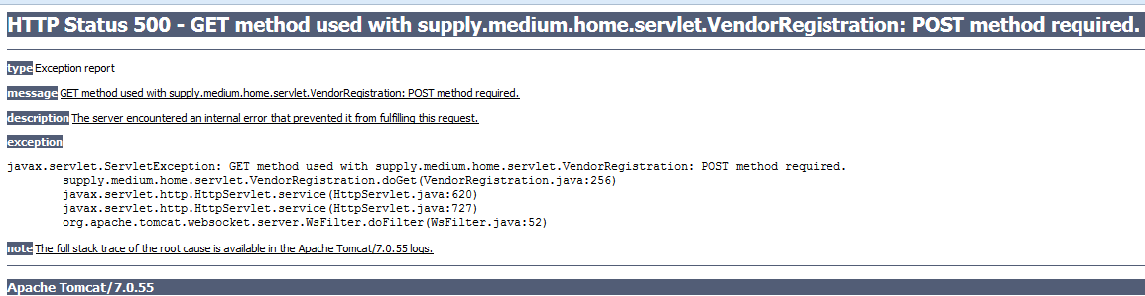

1. In the dashboard I get these numbers although I have not done any transactions

